Day 15 :

Question1

Design the database for a shop which sells products

Points for consideration

1) One product can be supplied by many suppliers

2) One supplier can supply many products

3) All customers details have to present

4) A customer can buy more than one product in every purchase

5) Bill for every purchase has to be stored

6) These are just details of one shop

Note:- you do not have to store the shop details.

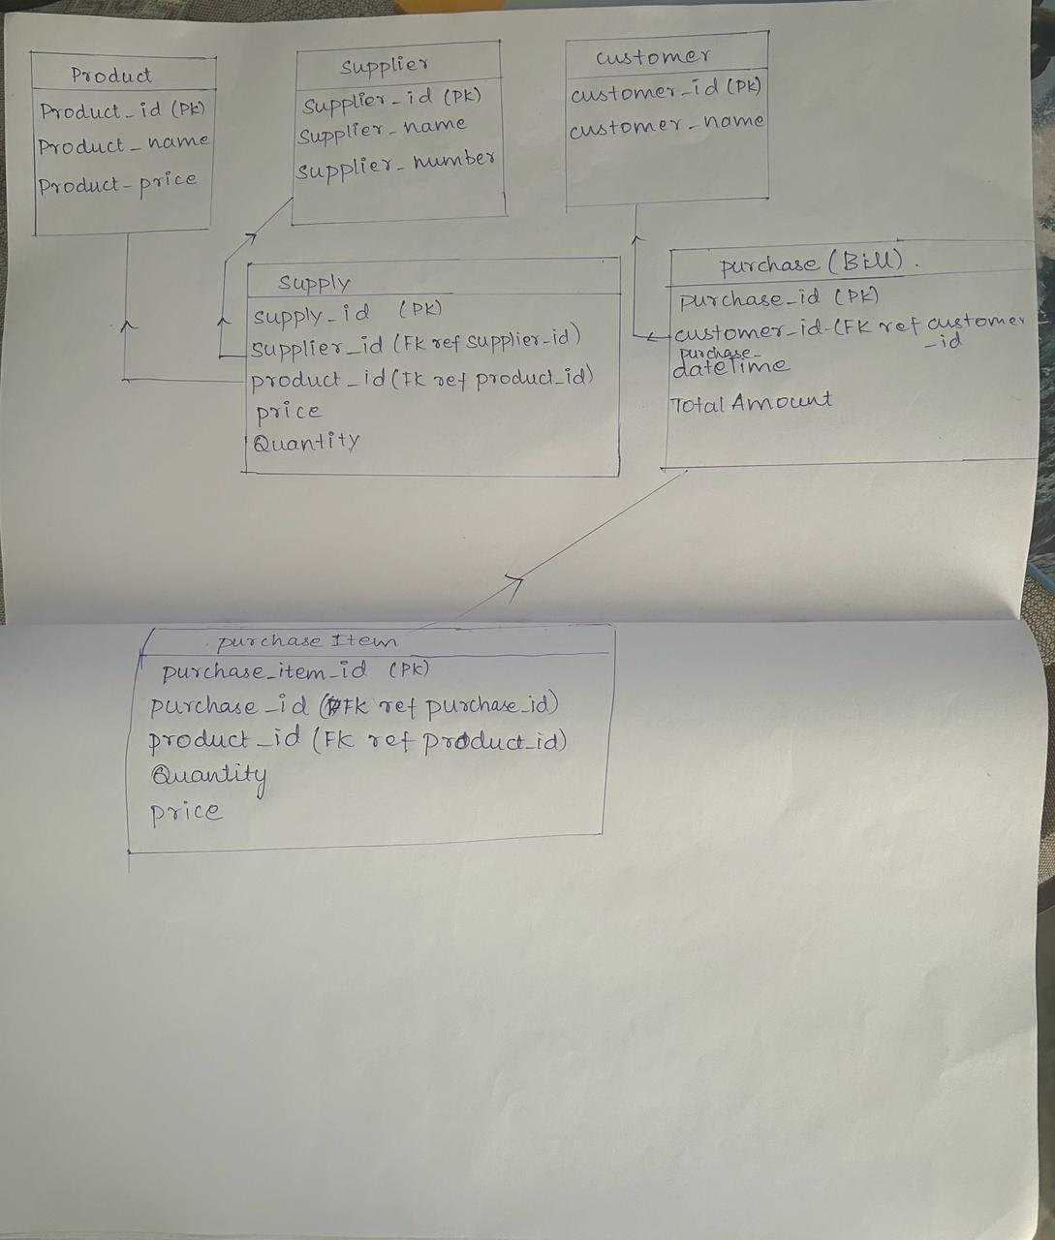

2. Question2

Case 1: A Simple Case on ER Modelling

• Goal – to demonstrate how to build an E-R model from a simple Statement of Objectives of a movie store. ( given very clearly in statement forms)

Scenario:

• A video store rents movies to members.

• Each movie in the store has a title and is identified by a unique movie number.

• A movie can be in VHS, VCD, or DVD format.

• Each movie belongs to one of a given set of categories (action, adventure, comedy, ... )

• The store has a name and a (unique) phone number for each member.

• Each member may provide a favorite movie category (used for marketing purposes).

• There are two types of members:

o Golden Members:

o Bronze Members:

• Using their credit cards gold members can rent one or more movies and bronze members max. of one movie.

• A member may have a number of dependents (with known names).

• Each dependent is allowed to rent one (1) movie at a time.

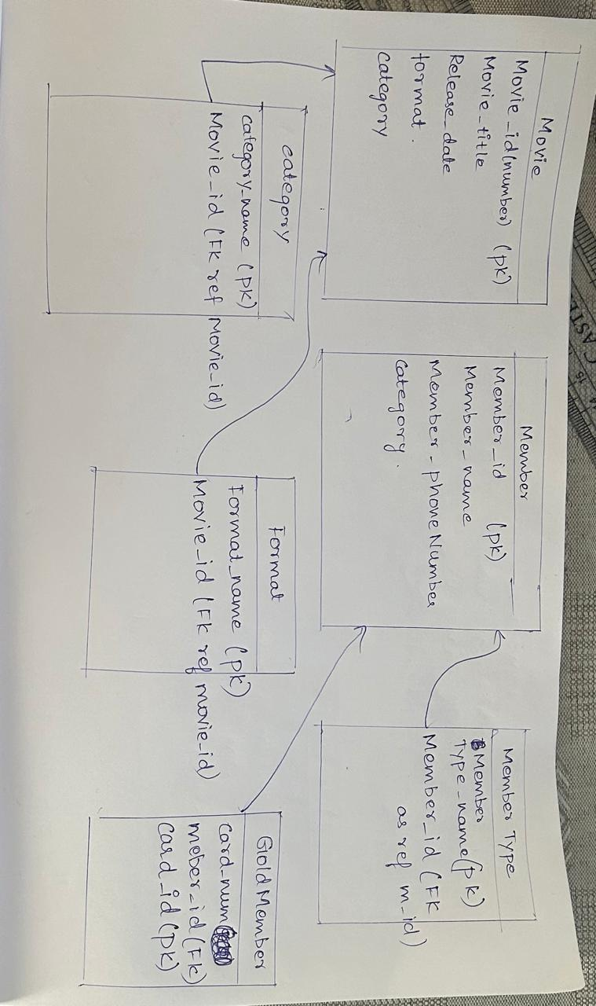

3 .

Creating employee table :

create table EMP

(Empno int NOT NULL,

Empname varchar(30),

Empsalary int,

PRIMARY KEY(Empno)

)

Creating department table :

create table department

(deptname varchar (30),

deptfloor int,

deptphone int,

MgrId int

Primary key (deptname)

)

Adding foreign key :

ALTER TABLE DEPARTMENT

ADD CONSTRAINT Fk_MgrId FOREIGN KEY (MgrId) References EMP(Empno)

Adding foreign key :

ALTER TABLE EMP

ADD CONSTRAINT Fk_DEPARTMENT FOREIGN KEY (DEPARTMENT) References Department(deptname)

Adding boss no column in emp table :

ALTER TABLE EMP

ADD bossno int NULL

Adding foreign key :

ALTER TABLE EMP

ADD Constraint Fk_boosno Foreign key (bossno) references EMP(empno)

Creating sales table :

create table sales

(salesno int,

Saleqty int,

Itemname varchar(20)not null,

deptname varchar (30) Not null,

Primary key (salesno)

)

Creating item table:

create table item

(

Itemname varchar(20),

itemtype char(1),

itemcolor varchar(10),

Primary key (Itemname)

)

Adding foreign key :

Alter table sales

Add constraint fk_itemname Foreign key (itemname) references item(itemname)

Alter table sales

Add constraint fk_deptname Foreign key (deptname) references department(deptname)

Inserting values in emp table:

insert into emp (empno , empname , empsalary) values ( 1 , 'alice' , 75000 )

Insert into emp values(2 , 'ned' , 450000 , 'management' ,1)

Inserting values in dept table :

insert into department values ('management' , 5 , 34 , 1)

Update values in emp table:

UPDATE emp

SET DEPARTMENT = 'management'

WHERE empno = 1;

fetching all data from emp table :

select * from emp

